**Login Feature Testing**

**Input Domain:**

Student ID: Text inputs including letters, numbers, and symbols

Password: Text inputs including letters, numbers, and symbols

**Equivalence Partitions/ Boundary Values:**

NA

**Test Cases:**

|  |  |  |  |  |  |  |
| --- | --- | --- | --- | --- | --- | --- |
| Test Case # | Test Steps | Student ID (Input) | Password (Input) | Expected Output | Actual Output | Result (Pass/Fail) |
| 1 | 1. Enter valid SID  2. Enter valid password  3. Click login button | 264853197 | validPass1? | Successful login | Successful login | Pass |
| 2 | 1. Enter valid SID  2. Enter invalid password  3. Click login button | 234865972 | invalidPass1? | Unable to sign in | Unable to sign in | Pass |
| 3 | 1. Enter invalid SID  2. Enter valid password  3. Click login button | 5648213 | validPass1? | Unable to sign in | Unable to sign in | Pass |
| 4 | 1. Enter invalid SID  2. Enter invalid password  3. Click login button | 3248516 | invalidPass1? | Unable to sign in | Unable to sign in | Pass |
| 5 | 1. Leave SID and password fields blank  2. Click login button |  |  | We found some errors. Please review the form and make corrections | We found some errors. Please review the form and make corrections | Pass |

**State Transition Diagram:**

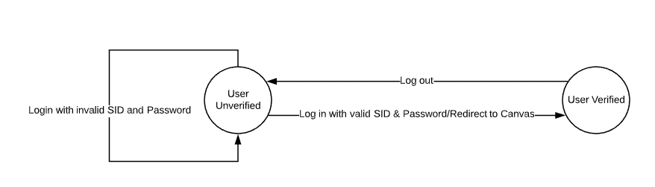

**Log In UI:**

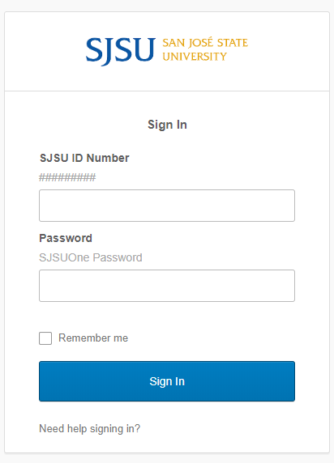

**Password Reset Feature Testing**

**Input Domain:**

Password: Text inputs including letters, numbers, and symbols

**Equivalence Partitions/ Boundary Values:**

NA

**Test Cases:**

|  |  |  |  |  |  |  |
| --- | --- | --- | --- | --- | --- | --- |
| Test Case # | Test Steps | Description | Password (Input) | Expected Output | Actual Output | Result (Pass/Fail) |
| 1 | 1. Enter password  2. Confirm Password  3. Click Continue | Valid password with 10-16 characters | Password54? | Password changed successfully | Password changed successfully | Pass |
| 2 | 1. Enter password  2. Confirm Password  3. Click Continue | Vald password with 17-28 characters | testInputPassword2 | Password changed successfully | Password changed successfully | Pass |
| 3 | 1. Enter password  2. Confirm Password  3. Click Continue | Non-unique password | pastPass16? | Please enter valid password | Please enter valid password | Pass |
| 4 | 1. Enter password  2. Confirm Password  3. Click Continue | Password with spaces | Pass word16? | Please enter valid password | Please enter valid password | Pass |
| 5 | 1. Enter password  2. Confirm Password  3. Click Continue | Password with no lowercase letters | PASSWORD32! | Please enter valid password | Please enter valid password | Pass |
| 6 | 1. Enter password  2. Confirm Password  3. Click Continue | Password with no capital letters | password32! | Please enter valid password | Please enter valid password | Pass |
| 7 | 1. Enter password  2. Confirm Password  3. Click Continue | Password with no numbers | Password! | Please enter valid password | Please enter valid password | Pass |

**Decision Table:**

|  |  |  |  |  |  |  |  |  |  |  |
| --- | --- | --- | --- | --- | --- | --- | --- | --- | --- | --- |
| Condition | Value | R1 | R2 | R3 | R4 | R5 | R6 | R7 | R8 | R9 |
| Length between 10-28 | Y/N/- | N | Y | Y | Y | Y | Y | Y | Y | Y |
| Length between 17-28 | Y/N/- | - | Y | Y | N | N | N | N | N | N |
| Contains no spaces | Y/N/- | - | - | - | N | Y | Y | Y | Y | Y |
| Contains at least one lower case letter | Y/N/- | - | - | - | - | N | Y | Y | Y | Y |
| Contains at least one capital letter | Y/N/- | - | - | - | - | - | N | Y | Y | Y |
| Contains at least one number | Y/N/- | - | - | - | - | - | - | N | Y | Y |
| Unique from past passwords | Y/N/- | - | N | Y | - | - | - | - | N | Y |
| **Effects** | | | | | | | | | |  |
| Password is approved |  |  |  | 1 |  |  |  |  |  | 1 |
| Password is rejected |  | 1 | 1 |  | 1 | 1 | 1 | 1 | 1 |  |
| **Checksum** | 128 | 64 | 16 | 16 | 16 | 8 | 4 | 2 | 1 | 1 |

**Password Reset UI:**

